Software Requirements Specification
for
English Dictionary
Version 1.0 approved
Prepared by
Nguyen Chau Thao Quan
Nguyen Hung Phuc

December 9, 2018
Table of Contents
1. Introduction 1
1.1 Purpose 1
1.2 Document Conventions 1
1.3 Definitions, Acronyms and Abbreviations 1
1.4 References 1
2. High Level Requirements 1
2.1 Product Perspective 1
Use Case Description 1
2.2.1 Diagram 1
2.2.2 User Description 3
2.2.3 Use Case Description 3
2.2.4 Use Case & User Permission Mapping 4
2.3 Operating Enviroment 4
2.4 Assumption and Dependencies 4
3. FUNCTIONAL REQUIREMENT 4
3.1 Module 01 4
3.1.1 UC01: Sign Up 4
3.1.2 UC02: Sign In 5
3.1.3 UC03: List of users 6
3.1.4 UC04: Account Personal Information 7
3.1.5 UC05: Search field 8
3.1.6 UC06: Language field 8
3.1.7 UC07: View History 9
4. Nonfunctional Requirements 9
4.1 Accessbility 9
4.2 Volume 9
4.3 Precision 9
4.4 Performance 10
4.5 Compatibility 10
4.6 Maintainability 10
4.7 Safety 10
4.8 Portability 10
5. System Constraint 10
5.1 Database 10
5.2 Device 10
5.3 Programming Language 10

Revision History
Name | Date | Reason For Changes | Version

Introduction

Purpose
This Software Requirement Specification version 1.0 provide a complete description of all the function and specification of the English dictionary project. This document is intended to sign the contract with the customer and to be used by the members of the software engineering team that will implement and verify the correct function of the system.

Document Conventions
None

Definitions, Acronyms and Abbreviations
# | Abbreviation | Explaination
1 | SRS | Software Requirement Specification
2 | UC | Use Case
3 | SC | Screen
4 | MS | Messages

References
Title | Author | Version | Date | Source Location

High Level Requirements

Product Perspective
This product use the translate technique which is similar to google translate system. When user search any word, it will show the English description, pronounciation and the meaning of that word, including the audio that will play all the English description, pronounciation.
GUI
DB

Use Case Description

Diagram
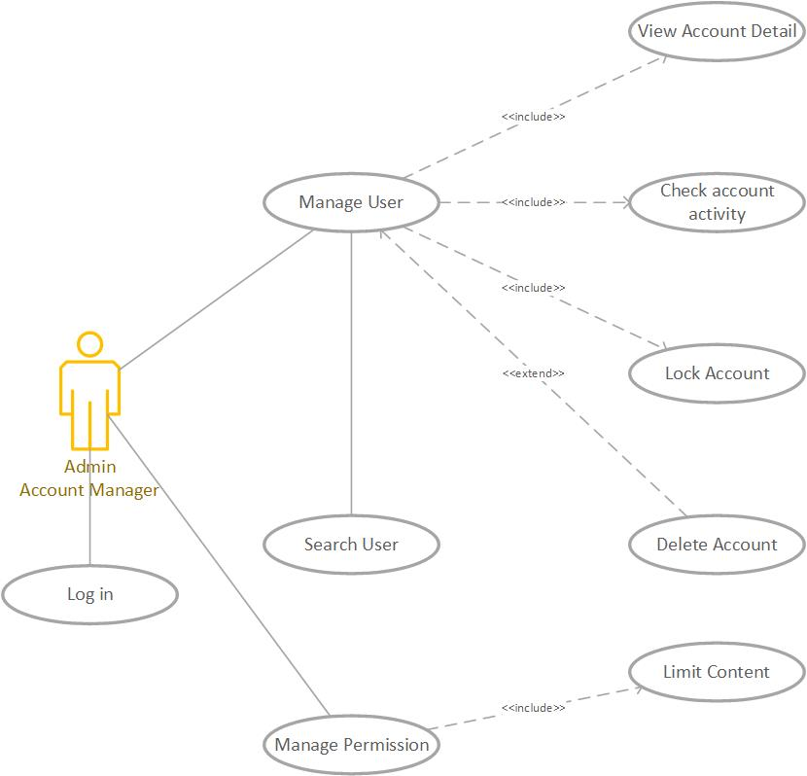
Diagram 1: Admin and Account Manager Permission
Notes: Admin and account manager can access all function

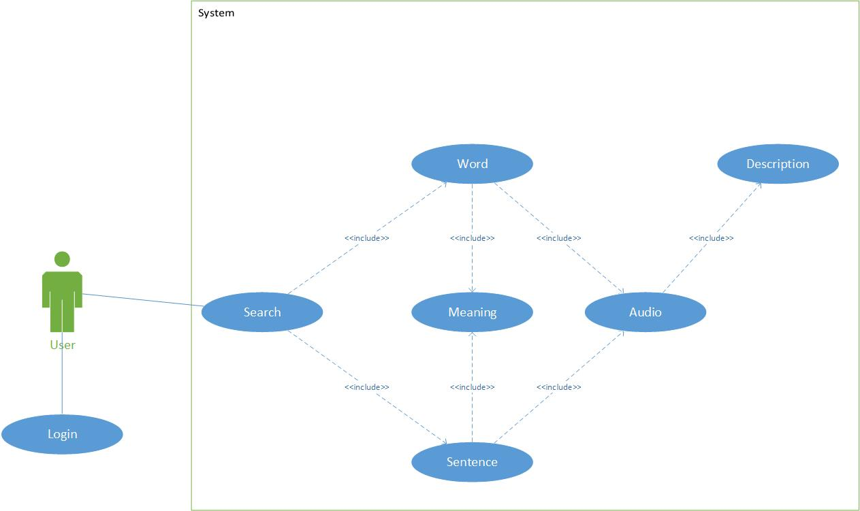
User Description
Diagram 2: Dictionary System
# | User Permission | Definition
1 | Admin
2 | Account Manager
3 | Guest

Use Case Description
# | ID | Name | Brief Description
1 | UC01 | Sign Up | User can create account to use the translate function
2 | UC02 | Sign In | User can Login when they create account success
3 | UC03 | List of user | Account Manager can see and manage the user account
4 | UC04 | Account personal information | User can see and change their personal information
5 | UC05 | Search field | User can enter the words or sentences to find the meaning
6 | UC06 | Description section | User can see the word they enter and the meaning of that one
7 | UC07 | Audio | User can hear the sound of that word
8 | UC08 | View History | User can see the words they enter all the times

Use Case & User Permission Mapping
Use Case | Use Case Name | Admin | Account Manager | Guest
UC01 | Sign Up | X | X | X
UC02 | Sign In | X | X | X
UC03 | List of user | X | X
UC04 | Account personal information | X | X | X
UC05 | Search field | X | X | X
UC06 | Language field | X | X | X
UC07 | View History | X | X | X

Operating Enviroment

Assumption and Dependencies

FUNCTIONAL REQUIREMENT

Module 01

UC01: Sign Up
terface (GUI) will benaging the cluster. Upors will be presented with a gdes in the managed cluster. There will a bent identifyg logged-in user. The GUI will theninterface wiystem. GUI navigation will follow common standards very si web pages son understood functions suchs, buttons, amatting.
ID | Name | Account | Trigger | Pre-condition | Post condition
UC01 | Sign Up | Admin/Account Manager/Guest | User press the Sign Up button |  | Move to Sign In form

Activities

User |  | System
Main flow: Sign Up Success
1 | User press sign up button. (SC01)
 |  | 2 | Move to the Sign Up forms. (SC02)
3 | User enter their name, email, password and tick the box I agree.
 |  | 4 | Validate the field and the check the password.

System Messages

MS01 | Please enter your name.
MS02 | Please enter your email.
MS03 | Please enter your password.
MS04 | The password is not matched.
MS05 | Cannot create account when the check box I agree is missing.

UC02: Sign In
ID | Name | Account | Trigger | Pre-condition | Post condition
UC02 | Sign In | Admin/Account Manager/Guest | User press the Sign In button |  | Move to homepage

Activities

User |  | System
Main flow: Sign In Success
1 | User press sign in button (SC02)
 |  | 2 | Move to the Sign Up forms (SC03)
3 | User enter their name, email, password and tick the box I agree
 |  | 4 | Validate the field and the check the password.

System Messages

MS06 | Please enter your name  This notification will appear when user let the name field is empty
MS07 | Please enter your email  This notification will appear when user let the email field is empty
MS08 | Please enter your password  This notification will appear when user let the password field is empty
MS09 | The password is not matched  This notification will appear when 2 password from input isn’t same
MS10 | Cannot create account when the check box I agree is missing  This notification will appear when user let the check box isn’t ticked

UC03: List of users
ID | Name | Account | Trigger | Pre-condition | Post condition
UC03 | List of users | Admin/Account Manager | Admin/Account Manager press the icon user button |  | Move to List of users

Activities

User |  | System
Main flow: Move to List of User successful
1 | User press the icon (SC04)
 |  | 2 | Show the list of users (SC05)
3 | Admin/Account manager can lock or set the permission of account

System Messages

MS11 | Set up complete  Admin/Account manager set the user permission successful
MS12 | Access denied  Account isn’t admin or account manager can’t access when Admin/Account manager lock that one

UC04: Account Personal Information

ID | Name | Account | Trigger | Pre-condition | Post condition
UC04 | Account Personal Information | Admin/Account Manager/Guest | User press the Account detail |  | Move to personal information page

Activities

User |  | System
Main flow: Sign Up Success
1 | User press personal information detail(SC06)
 |  | 2 | Move to the personal information page (SC07)
3 | User enter their new name, email, password.
 |  | 4 | Validate the field and the check the password by request their password again.
5 | User enter the password to confirm
 |  | 6 | Notice when user type successful or not

System Messages

MS13 | Password is not match  this message will appear when 2 password from user are not match

UC05: Search field

ID | Name | Account | Trigger | Pre-condition | Post condition
UC05 | Search field | Admin/Account Manager/Guest | Admin/Account Manager/Guest enter any word or sentences and press search button. |  | Find the specific word to translate.

Activities

User |  | System
Main flow: Search successful
1 | User enter the words or sentences.
 |  | 2 | Check this is words or not  Check this is sentences or not.
3 | Translate from English to Vietnamese or vice versa.

System Messages

MS11 | This is not the words  The word or sentence that user entered contain the special characters.

UC06: Language field
ID | Name | Account | Trigger | Pre-condition | Post condition
UC06 | Language field | Admin/Account Manager/Guest |  |  | Translate a word or a sentence from English to Vietnamese or vice versa

Activities

User |  | System
Main flow: Search successful
1 | Enter a word which don’t have any special characters.
 |  | 2 | Translate this word from English to Vietnamese when user enter the word to search correct.

UC07: View History
ID | Name | Account | Trigger | Pre-condition | Post condition
UC07 | View History | Admin/Account Manager/Guest | Admin/Account Manager/Guest click the view history button |  | See the word they looked up

Activities

User |  | System
Main flow: View History page
 |  | 1 | Show the user the word history list

Nonfunctional Requirements

Accessbility
User enter 1 character and show the list of the words that have that character.
User can use their voice to fill the word automatically.

Volume
Number of user can access at least 100 peoples.

Precision
The word must be translated when the words or sentenced have uppercases in any location.
The word received from user’s voice must be filled corect.
Audio must be spoken correct depends on the description.

Performance
The word that user look up show the result under 5s.
The web application is responsive.

Compatibility
The application must run on web browser.
The application run on windows 7 or higher.

Maintainability
All functions can be possibly colliped.

Add more functions when needed.

Safety
The account management system will check the account activity when the bad behavior appear (pollitic, system security,…).

Portability
The application run on device with any hardware:

- PC or laptop with minimum CPU core 2 duo, 2GB of rams or modern one.

System Constraint

Database
The application translate the word through firebase or MySQL

Device
The application run only on destop or laptop.

Programming Language
Can write with the scripting language(HTML/CSS,JavaScript,PHP,...) or high level language (C/C++, python,java,...).

